# 亚信资源归档-外挂功能交维文档

背景：需要处理亚信资源归档上线前派发的还是在途的工单，需要在满足条件下进行调用亚信资源归档接口。

需求提供的处理execl文档：

改造逻辑：

一、新增亚信资源归档外挂程序

kettle-job-cancel-day模块新增执行器配置-亚信资源归档

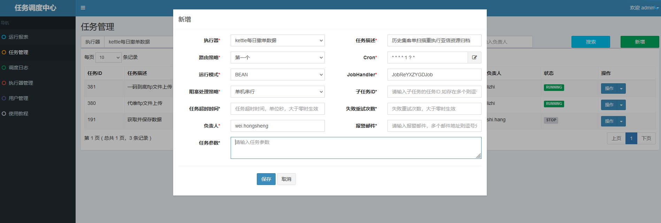

1、执行入参：{startDate:"2021/09/05 00:00:00",endDate:"2021/09/10 00:00:00","model":0}

2、所有参数均为可选，不选择时，默认查询时间为2000年1月1日到2022年9月21号6点前的在途集客工单（业务类型读取至nacos配置IOM-ORDER空间下：JOB_RE_YXZYGD_CONFIG项的needProduct）。

3、model参数可选配置项为0、1、2，其它值均会默认为0，不输入时，默认为0。当model为0时，会采集入参时间内的在途集客工单与OM_ORDER_RE_YXZYGD表内state为“10I”的数据项的记录；当model为1时，仅采集入参时间内的在途集客工单；当model为2时仅采集OM_ORDER_RE_YXZYGD表内state为“10I”的数据项的记录。

4、采集记录后，使用记录的serviceId与nacos配置JOB_RE_YXZYGD_CONFIG项的needRule内容进行比对。当对应记录的serviceId在needRule中，流程版本与version内配置的版本一致且环节id存在tache中，则会进行数据下发至对应亚信资源归档接口，然后保存调用记录至OM_ORDER_RE_YXZYGD表。

Nacos配置：

IOM-ORDER

data_id:JOB_RE_YXZYGD_CONFIG

{

"needProduct":"220596|220595|220454|220453|220474|220473|220479|220480|220576|220575|220594|240632|220593|230632|1270632|1230632|1240632|220653|220674|220654|220679|220680",

"needRule":{

"220596":{"version":"[1.0][1.1]","tache":"116136","name":"和商务TV-拆机"},

"220595":{"version":"[1.0][1.1][1.3]","tache":"116136","name":"和商务TV-新装"},

"220454":{"version":"[1.0]","tache":"100043|113234|115872|115873|115875|115877|115899","name":"互联网专线快开-拆机"},---

"220453":{"version":"[1.0][1.1][1.2][1.3][1.4][1.5][1.6][1.7][1.8][1.9][2.0][4.0]","tache":"113232|115872|115873|115875","name":"互联网专线快开-新装"},

"220474":{"version":"[1.0][1.1][1.2][1.3][1.4]","tache":"100043|113134|113232|113234|115875|115876|115877|115899|926189","name":"互联网专线快开-移机"},

"220473":{"version":"[1.0][1.1][1.2]","tache":"100044|115873|115875","name":"互联网专线快开-IP地址调整"},

"220479":{"version":"[1.0]","tache":"115875","name":"互联网专线快开-扩容"},

"220480":{"version":"[1.0]","tache":"115875","name":"互联网专线快开-减容"},

"220576":{"version":"[1.0][1.1]","tache":"116140","name":"企业云视讯-拆机"},

"220575":{"version":"[1.0][1.1][1.3]","tache":"116140","name":"企业云视讯-新装"},

"220594":{"version":"[1.0][1.1]","tache":"116140","name":"企业云视讯-移机"},

"240632":{"version":"[1.0][1.1][1.3]","tache":"116131","name":"千里眼-拆机"},

"220593":{"version":"[1.0][1.1][1.2][1.3]","tache":"116131","name":"千里眼-新装"},

"230632":{"version":"[1.0][1.1][1.3]","tache":"116131","name":"千里眼-移机"},

"1270632":{"version":"[1.0][1.1][1.2][1.3][1.4]","tache":"100043|113234|115872|115873|115875|115877|115899","name":"商务快线-拆机"},

"1230632":{"version":"[1.0][1.1][1.2][1.3][1.4][1.5][1.6][1.7][1.8][1.9][2.0][3.0][6.0][7.0]","tache":"113232|115873|115875","name":"商务快线-新装"},

"1240632":{"version":"[1.0][1.1][1.3]","tache":"100043|113134|113232|113234|115875|115876|115877|115899|926189","name":"商务快线-移机"},

"220653":{"version":"[1.0][1.1][1.2][1.3][1.4][1.5][1.6][1.7][1.8][1.9][2.0][3.0][4.0][6.0]","tache":"113232|1146189","name":"语音专线快开-新装"},

"220674":{"version":"[1.0][1.1][1.2]","tache":"113134|113232|113234|115875|115876|115877|115899|926189|1136189","name":"语音专线快开-移机"},

"220654":{"version":"[1.0]","tache":"113234|926189|1146189","name":"语音专线快开-拆机"},

"220679":{"version":"[1.0]","tache":"1146189","name":"语音专线快开-扩容"},

"220680":{"version":"[1.0]","tache":"1146189","name":"语音专线快开-减容"}

},

"resArchive":{

"220453":"Y","220474":"Y","1230632":"Y","1240632":"Y","220653":"Y","220674":"Y","220593":"Y","230632":"Y","220575":"Y","220594":"Y","220595":"Y"

},

"updateLine":{

"220454":"Y","1270632":"Y","220654":"Y","240632":"Y","220576":"Y","220596":"Y"

},

"modifyLine":{

"220479":"Y","220480":"Y","220473":"Y","220679":"Y","220680":"Y"

}

}

说明：

needProduct:业务开关

needRule:业务流程版本、环节配置

resArchive：资源归档调用的业务类型开关-Y开

updateLine：资源更新通知调用的业务类型开关-Y开

modifyLine：资源变更通知调用的业务类型开关-Y开

5、扫描到的工单记录到select * from gx_oss.OM_ORDER_RE_YXZYGD a表。

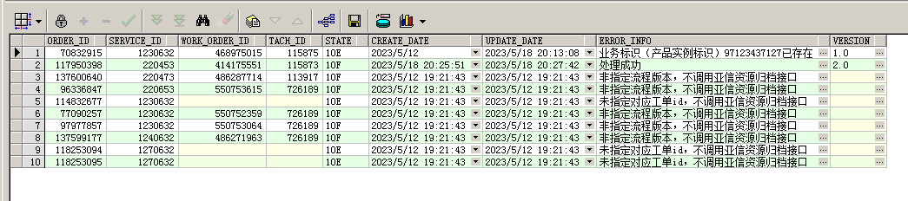

1. 执行后XXL-JOB会调用brick-group-construct-web模块接口进行亚信资源归档。

*--查询脚步*

select oo.id,

oo.service_id,

up.version,

t.tache_define_id,

t.id as wo_work_id

from uos_processdefine up, uos_processinstance upe, om_order oo

left join (select *

from (select b. *,

(row_number()

over(partition by b.base_order_id order by

b.create_date)) rn

from wo_work_order b) e

where rn = 1) t

on oo.id = t.base_order_id

where oo.processinstanceid = upe.processinstanceid

and upe.packagedefineid = up.packagedefineid

and not exists

(select 1

from OM_ORDER_RE_YXZYGD oory

where oory.ORDER_ID = oo.id

and oory.STATE = '10F')

and oo.order_state = '10N'

and oo.service_id in ('220596',

'220595',

'220454',

'220453',

'220474',

'220473',

'220479',

'220480',

'220576',

'220575',

'220594',

'240632',

'220593',

'230632',

'1270632',

'1230632',

'1240632',

'220653',

'220674',

'220654',

'220679',

'220680')

and oo.create_date >=

to_date(#{startDate, jdbcType = VARCHAR}, 'yyyy/mm/dd hh24:mi:ss')

and oo.create_date <=

to_date(#{endDate, jdbcType = VARCHAR}, 'yyyy/mm/dd hh24:mi:ss');

---

select oo.id,

oo.service_id,

wwo.id,

wwo.tache_define_id,

'10I',

sysdate,

sysdate,

'',

upd.version

from gx_oss.om_order oo,

gx_oss.uos_processinstance upi,

gx_oss.uos_processdefine upd,

gx_oss.wo_work_order wwo

where oo.processinstanceid = upi.processinstanceid

and upi.packagedefineid = upd.packagedefineid

and wwo.id = (select max(wwo1.id)

from gx_oss.wo_work_order wwo1

where wwo1.base_order_id = oo.id)

and oo.id = '117950398';